JAVA CREDIT CARD PAYOFF
LAB ASSIGNMENT AND LAB REPORT
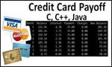
Name and Student ID: Jibran Akhter - 1073973
Date project completed: 3/16/2024
Platform (Mac, PC, Linux, etc.): Windows 11 PC
Development system (onlineGDB, NetBeans, Eclipse): onlineGDB

OBJECTIVES
Implement code using a loop to determine when a credit card is paid off
Use If/else statements to limit statements to 12 months
Determine if the balance exceeds the credit limit

PROJECT DESCRIPTION
Modify an existing program to incorporate the following updates
- Have the program prompt and enter values for the starting balance, any additional charges and a payment for each month. Use the same value for payment and charges for each month.
- Use a loop that displays the starting balance for the month, any additional charges, and the payment. The loop is also to compute and display the new balance after the charges have been added and the payment subtracted. If the scheduled payment is greater than the balance for the month plus the charges, change the payment amount to the balance plus charges to prevent the balance from becoming negative.
- End the loop for any of the following conditions
- twelve months have been displayed and there is still a balance due
- the balance is zero. Display a message "Balance is zero"
- the balance is greater than the credit limit. Display "Balance is greater than the credit limit"

ADDITIONAL INFOMATION

a) Code to get started on the project is located at the following locations:
C -language version is at http://program-info.net/C++/downloads/C++CreditCard/C-CreditCard.c
C++ language version is at http://program-info.net/C++/downloads/C++CreditCard/C++CreditCard.cpp
Java version is at http://program-info.net/Java/downloads/JavaCreditCard/JavaCreditCard.java
Feel free to use only your own code if you wish.

b) Information about the lab assignment
Video presentation on YouTube: https://youtu.be/L7EgFYvyGno
Video presentation on 3cMedia:
https://www.3cmediasolutions.org/privid/336372?key=dd9a285645f167c822c044f1a427b73146706395
PDF presentation is at: http://program-info.net/C++/downloads/C++CreditCard/C++CreditCardPPT.pdf

DISCUSSION
What did you do to develop the program? ("Followed the Directions" is not a complete description

First, I carefully read through the instructions to understand what the program needed to do. Then, I started laying out the basic structure of the program, setting up placeholders for where user input and calculations would go.

Next, I thought about how the program would interact with the user. I knew I needed to prompt them for the starting balance, any additional charges they might have, and the payment they wanted to make each month. So, I added code to ask the user for these values using a friendly message.

After gathering the user's input, I moved on to the heart of the program: the loop. This loop would go through each month, calculating the interest, adjusting the payment if needed, and figuring out the new balance. I wanted to make sure the user's payment didn't exceed their balance plus charges, so I added a check for that.

Inside the loop, I made sure to display all the important details for each month in a neat table format, so the user could easily see what was happening to their balance over time.

Then came the part where the program needed to decide when to stop. I added checks to see if twelve months had passed, if the balance hit zero, or if it exceeded the credit limit. Depending on which condition was met, I made sure the program displayed the appropriate message to the user.

Finally, I tested the program with different scenarios to make sure it worked as expected. After fixing a few bugs and making some tweaks, the program was ready to go!

What problems did you have and how did you overcome the problems?
During the development of the program, I encountered a few challenges, but I managed to overcome them effectively:

A challenge was to that the program adjusted the payment amount if it exceeded the balance plus charges for the month. To overcome this, I implemented a conditional check inside the loop to compare the payment amount with the balance plus charges. If the payment exceeded this amount, I set the payment equal to the balance plus charges to prevent the balance from becoming negative.

Determining when to end the loop posed a challenge too, as the program needed to check for multiple termination conditions, including reaching twelve months, reaching a zero balance, or exceeding the credit limit. To address this, I carefully structured the loop to include checks for each of these conditions and terminate the loop accordingly.

SCREENSHOTS
Capture only the portion of the screen that shows the calculator or program output. Do not capture the entire screen even though it may also contain the program output. If I need to zoom in on a screenshot, sometimes the image resolution is so poor that I am not able to read it. If this happens, I will ask that you resubmit your lab report. Refer to these instructions capturing screenshots and pasting them to the lab report.

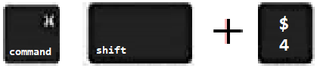
For the Mac
- hold down command + shift keys and press the 4 key
to get a screenshot of a selected area of the screen
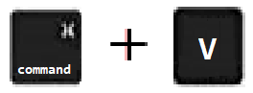
- Use the mouse or touchpad to select the desired area of the screen you want to save
- use command+V to paste into the lab report

For Windows

- use Microsoft's Snipping Tool by holding down the
Windows and Shift keys and tapping the ‘S’ key
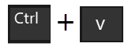
- Use the mouse or keypad to select the part of the screen you want to save
- use Ctrl+V to into the lab report

Paste three screenshots here
Screenshot #1:
Set the starting balance to 240.75, payment of 35.00, no additional charges, and a credit limit of 500.00

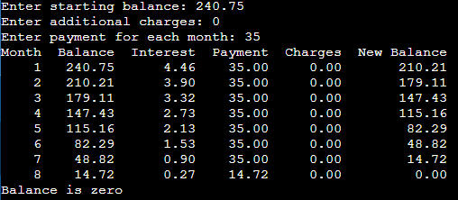

Screenshot #2:
Set the starting balance to 240.75, payment of 35.00, a charge of 20.00 each month, and a credit limit of 500.00
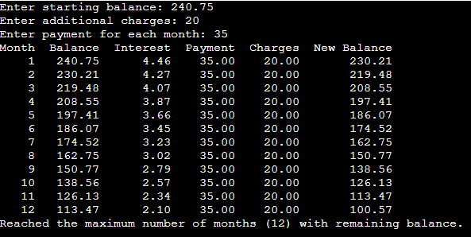

Screenshot #3:
Set the starting balance to 240.75, payment of 35.00, a charge of 60.00 each month, and a credit limit of 500.00
